23PA1A05G6
Part 1 – Interview Warm-up
1. What is a Validation Rule?
- A Validation Rule is a Salesforce feature that checks whether the entered data is correct before saving the record.
- It prevents users from saving records that do not follow the business rules.
- If the data is invalid, Salesforce shows an error message and does not save the record.

2. What is a Flow?
- A Flow is a Salesforce automation tool that performs tasks automatically without writing code.
- It can update records, create records, send emails, and automate business processes.
- Flows help reduce manual work and save time.

3. What is an Apex Trigger?
- An Apex Trigger is Apex code that runs automatically when a record is created, updated, deleted, or restored.
- It is used to handle complex business requirements that cannot be completed using Flows or Validation Rules.
- Triggers give developers more control over automation.

4. When would you choose a Flow instead of a Trigger?
- I would choose a Flow when the requirement can be completed without writing code.
- A Flow is easier to build, understand, and maintain.
- I would use a Trigger only if the business logic is too complex for a Flow.

5. Can a Validation Rule update another field? Why or why not?
- No, a Validation Rule cannot update another field.
- Its only purpose is to check whether the entered data is valid.
- If the data is invalid, it stops the record from being saved and shows an error message.

6. Which executes first: Validation Rule, Flow, or Trigger?
- A Before-Save Flow executes first.
- Next, Salesforce checks the Validation Rules.
- Then, the Before Trigger executes if one exists.

7. What is a Record-Triggered Flow?
- A Record-Triggered Flow is a Flow that runs automatically when a record is created, updated, or deleted.
- It does not require the user to start it manually.
- It is used to automate tasks such as updating fields, creating related records, or sending emails automatically.

Part 3 – Design Challenge
Requirement | Validation Rule / Flow / Trigger / Why?
Reject duplicate applications | Validation Rule – It prevents duplicate applications from being saved by checking the data before the record is saved.
Auto-fill Application Date | Flow – It automatically fills the Application Date when a new application is created without writing Apex code.
Send Email | Flow – It automatically sends an email notification to the Placement Officer after an application is submitted.
Reject low CGPA | Validation Rule – It checks whether the student's CGPA meets the minimum requirement and prevents the application from being saved if it does not.
Create Offer Letter record | Flow – It automatically creates an Offer Letter record when the application Status changes to Selected.

Part 4 – Hands-on Assignment
Flow Canvas
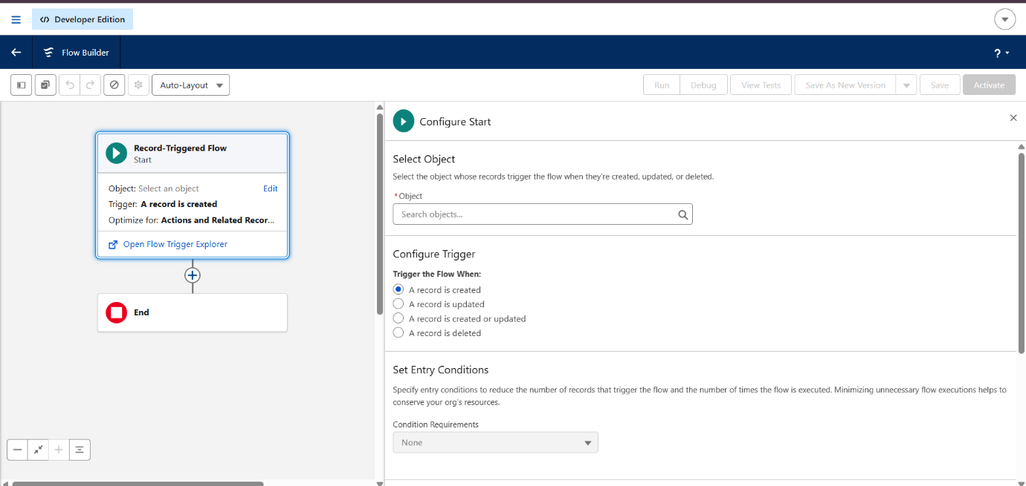
Start Element
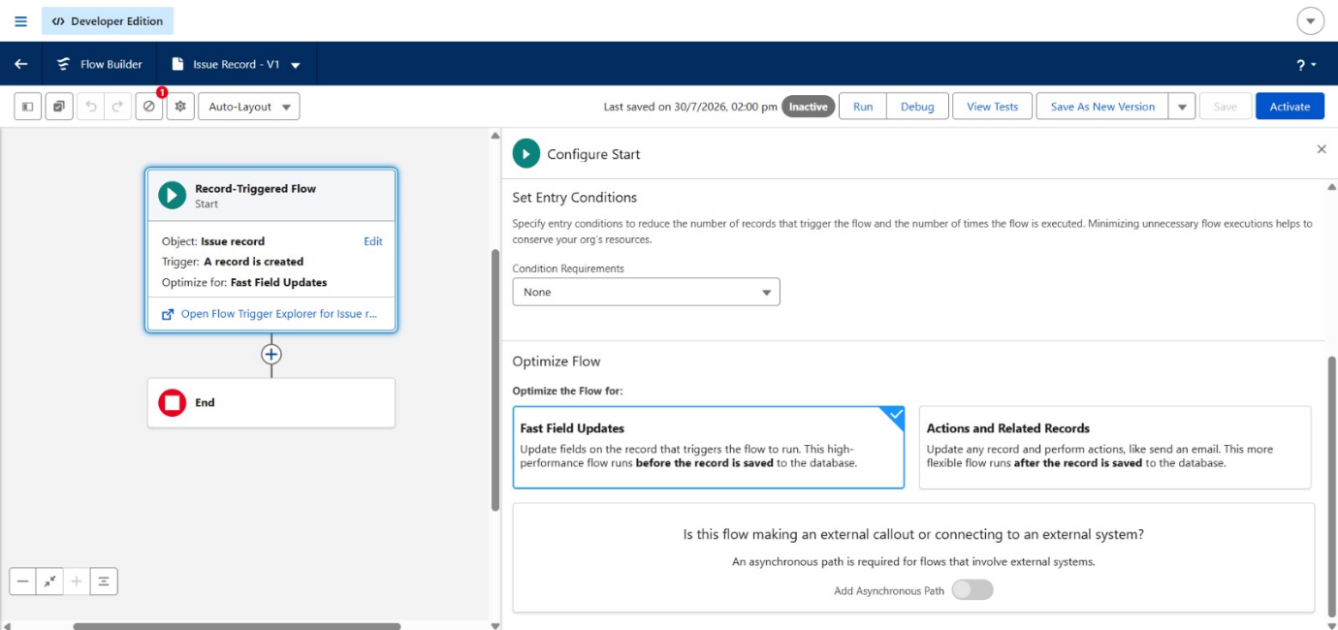
Assignment Element
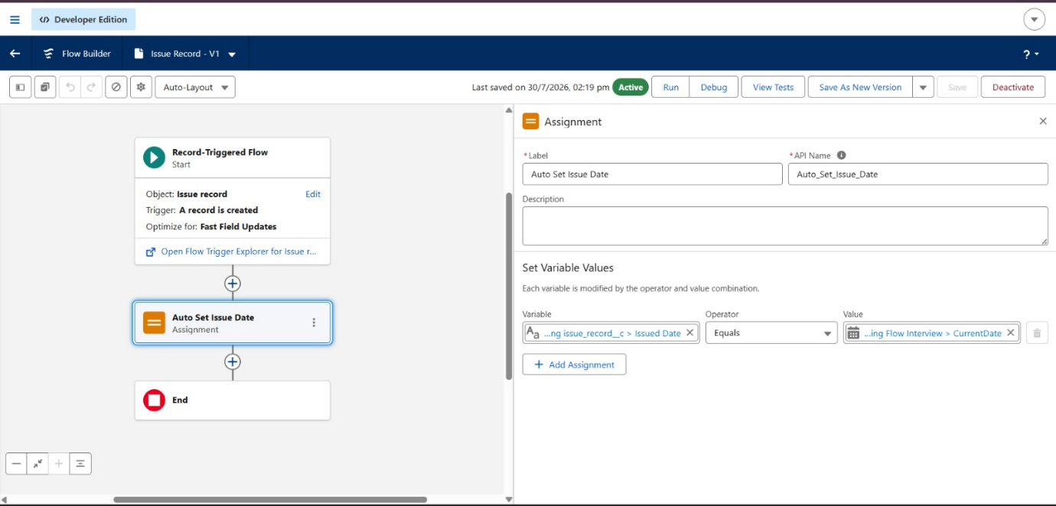
Email Action
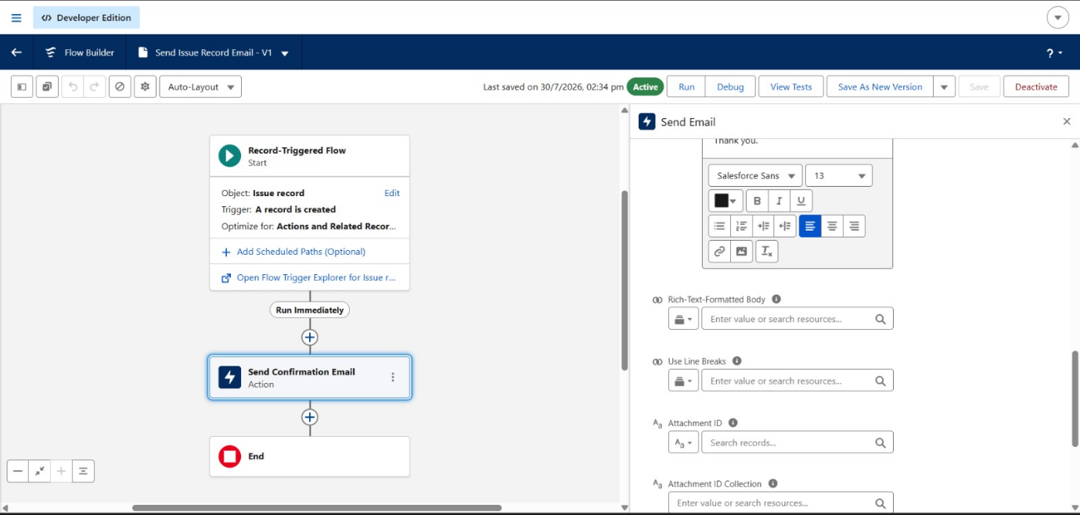
Successful execution
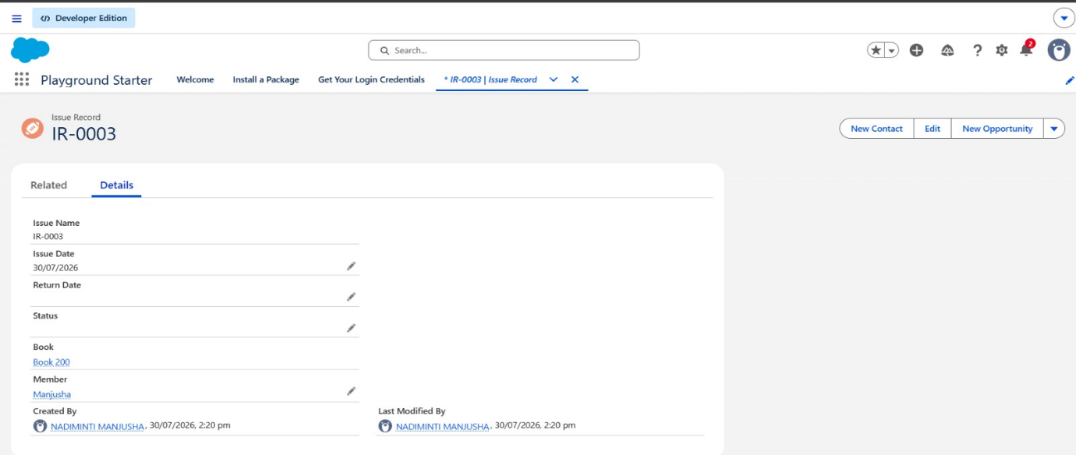

Part 5 – Validation Rule Challenge
Student CGPA must be greater than or equal to the Job's minimum CGPA.
RULE:
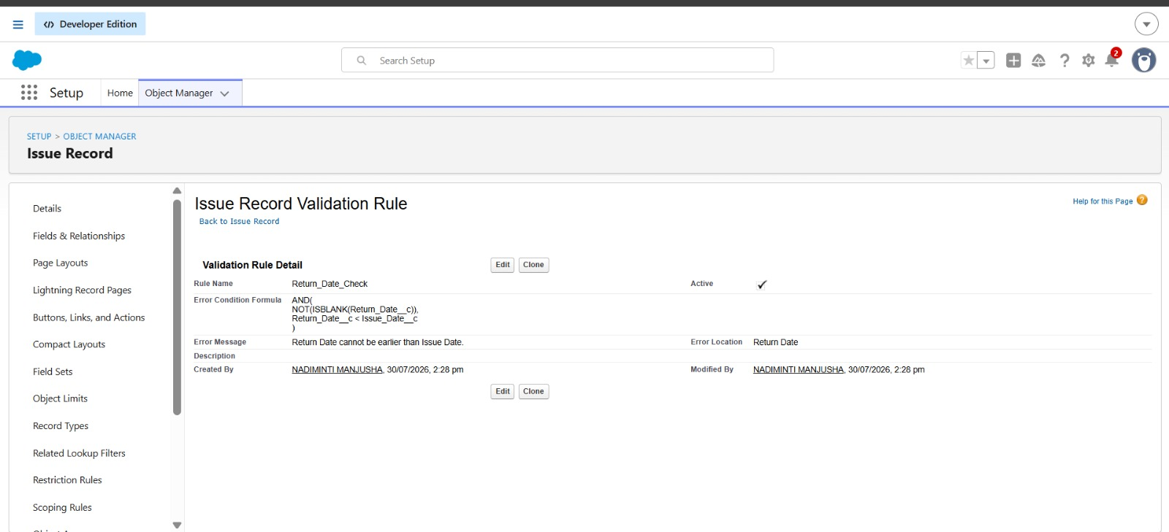
EXECUTION:
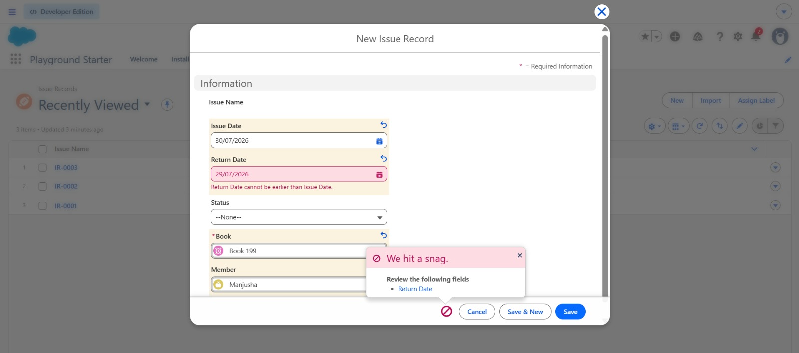
Application Date cannot be after the Job Closing Date.
RULE:
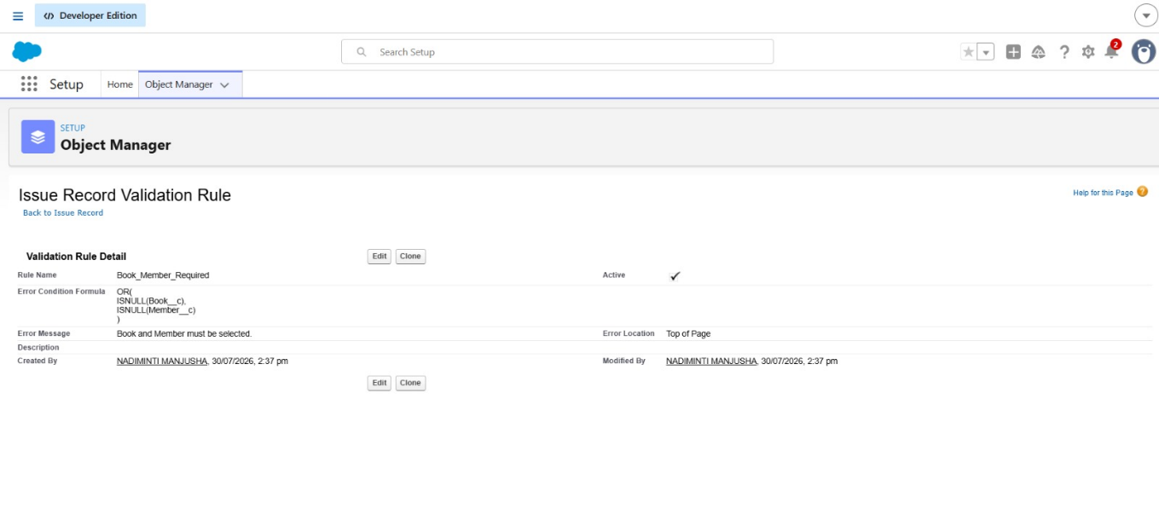
EXECUTION:
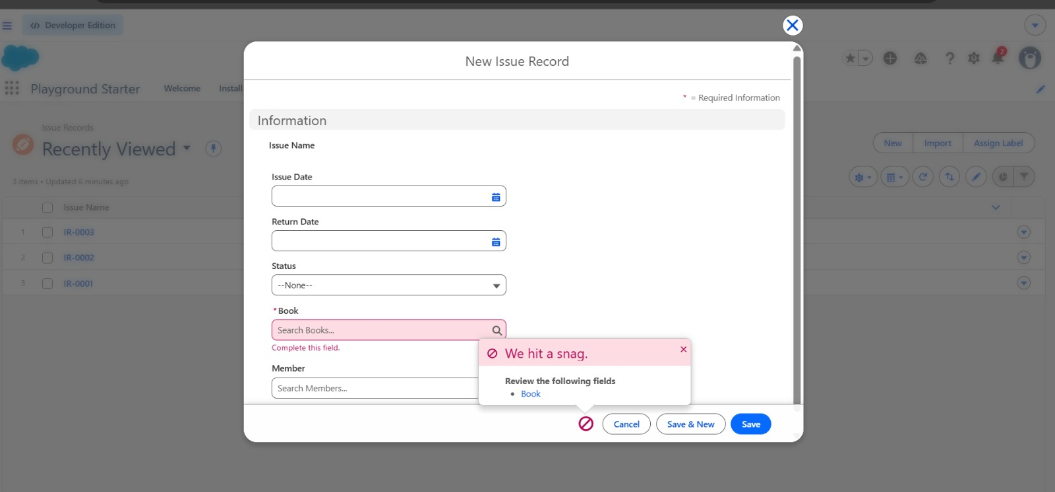
Mandatory fields cannot be left blank.
RULE:
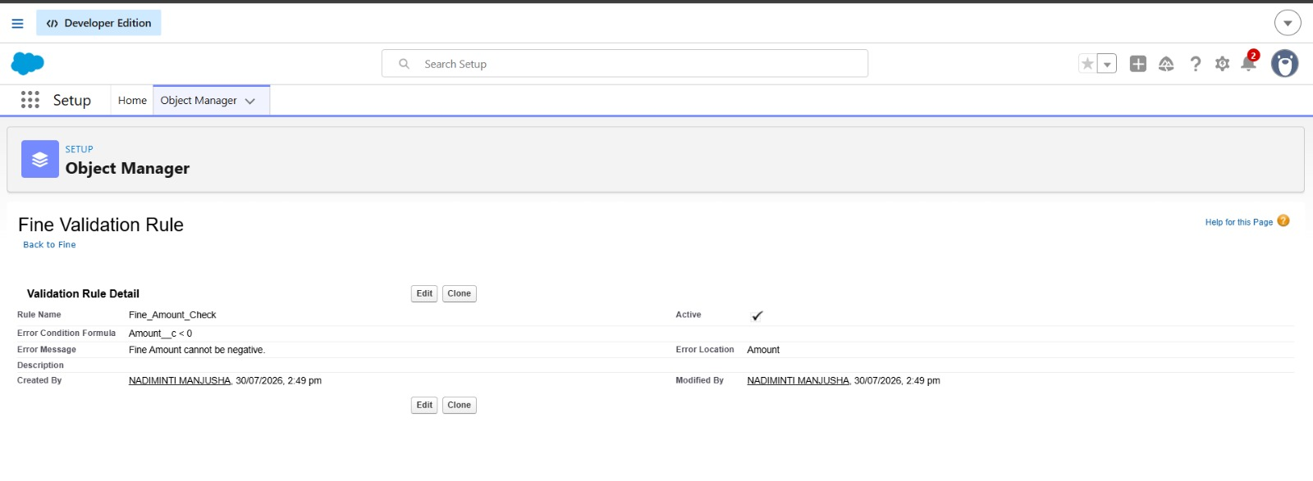
EXECUTION:
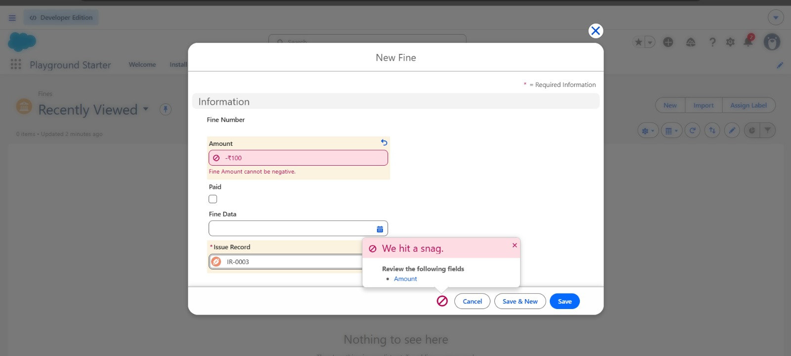

Part 6 – Trigger vs Flow Debate
1. Update a field automatically.
I would use a Flow because it can automatically update field values without writing Apex code. It is simple to build and is the recommended declarative solution for field updates.

2. Create a related record.
I would use a Flow because it can automatically create related records whenever a record is created or updated. This can be done without writing Apex code.

3. Send an email notification.
I would use a Flow because it has a built-in Send Email action that allows email notifications to be sent automatically when specific conditions are met.

4. Call an external REST API.
I would use an Apex Trigger because calling an external REST API requires Apex callouts. A Flow alone cannot handle complex API integrations in the same way.

5. Perform complex calculations involving multiple objects.
I would use an Apex Trigger because it can handle complex business logic, advanced calculations, and operations involving multiple related objects more efficiently than a Flow.

6. Process 10,000 imported records.
I would use an Apex Trigger because it can be written using bulk processing techniques to efficiently handle large numbers of records while following Salesforce governor limits.

Part 7 – Mini Project Enhancement
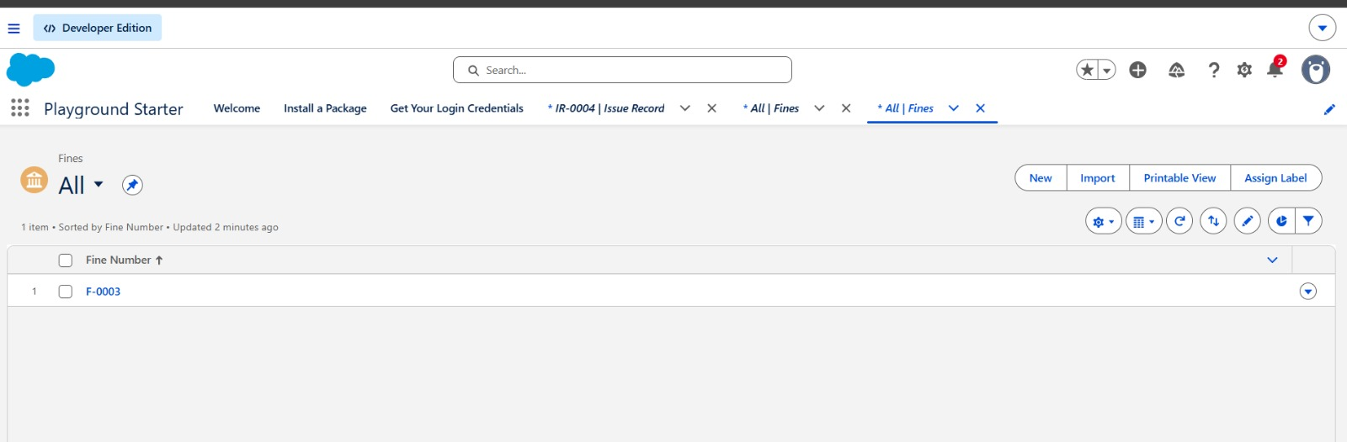
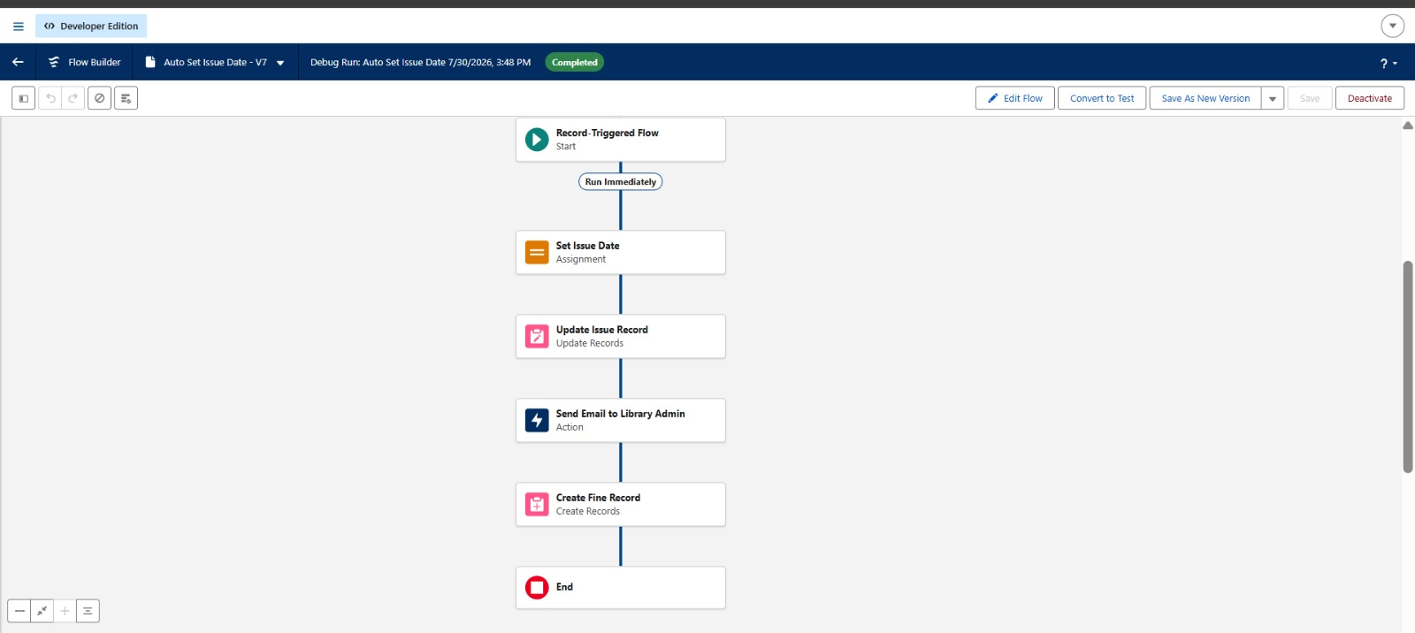

Part 8 – Debugging Challenge
1. What problem might occur?
The Trigger, Flow, and Workflow are all updating the same Status field. This can cause conflicts, inconsistent data, and make it difficult to determine which automation made the final update.

2. Could automation repeatedly execute?
Yes. When one automation updates the Status field, it can trigger another automation to run again. This can lead to repeated execution (recursion), unnecessary processing, and may even hit Salesforce governor limits.

3. How would you redesign this solution?
I would avoid using multiple automations for the same task. I would use a Record-Triggered Flow for simple automation, such as updating the Status or sending emails. I would use an Apex Trigger only if the business logic is too complex for a Flow. This makes the solution easier to maintain, improves performance, and prevents automation conflicts.

